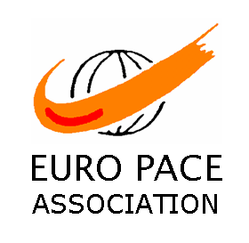  EURO PACE ASSOCIATION  5, chemin Messire Gauvain  35740 PACE ( FRANCE )  Telephone and Fax:00 33 2 99 60 17 12  Internet site:http://www.europace.fr  Your contact: Catherine IZABEL  Email: europace.basket4@orange.fr | 28th Under 13s basketball  INTERNATIONAL  (near RENNES in BRITANNY)  March 31st and April 1st, 2012

Dear friends,

We organize the 28th international tournament of Pacé on March 31st and April 1st 2012, and would be very happy to count you among the invited teams ( 28 – 30).

Please find attached some information regarding the tournament.

To help us better organise this sporting event, we would ask you to enrol as soon as possible (before December 1). Just fill out the attached form and return it to us.

On receiving your form, we will send you supplementary information. Please note the date of reception of completed enrolment forms will be taken into account in the confirmation of the participation of teams.

We look forward to seeing you very soon here in Pacé.

Best regards

All the team at the Euro Pacé Association,

Your contact : Catherine IZABEL

